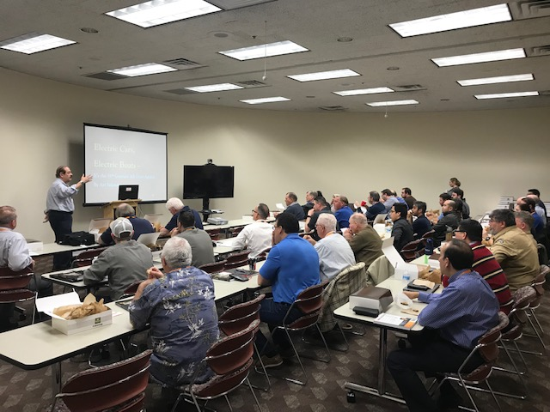
The HindleInstitute provides courses, events, webinars and technical training at no cost to our industry participants. Whether it is a live webinar, scheduled meeting, training course or just a “bunch of questions” we are here to help using either our personnel or seeking out an industry expert.

HindleInstitute Summer Learning Festival!
Date: Wednesday, August 10th 2022
Both Live at HindlePower & Virtual.
Earn CEU credit!
www.hindlepowerinc.com/about-us/upcomingevents
HindleInstitute is the premiere utility dc industry education resource.
Drawing on an accumulated knowledge base gathering since the early 1970s, HindlePower believes it is important to share this information with our industry and has developed the HindleInstitute to meet these industry needs.

The Festival Program:
(Formal agenda to follow.)
Along with the following topics, we will offer at no cost, lunch, coffee, snacks and more! Additionally, we will provide a listing of great local events such as Music Fest 2022, and you will have access to New York City and Philadelphia, both easily accessible form Easton, PA. We are conveniently located with access via highways, several airports and bus terminals. We will also provide you with lodging recommendations offering preferred HindlePower rates!
8:00 AM – 9:00 AM – Arrival, meet and greet, coffee, tea pastries

9:00 AM- 9:15 AM – Opening Remarks and Introduction

9:15 AM – 10:00 AM – HI101, Battery History
Take a step back in time and learn about the beginning uses of batteries through the early applications in the 1700s with the Leyden Jar in a carnival “Kissing Game.” Learn about the evolution from communications to transportation and electric lighting in the World’s Columbian Exposition of 1893, (Actual artifacts from the 1893 Exposition will be available for viewing.), early power plants, electric cars, and boats will be discussed. This is a fun and educational experience to see where it all began and where it might be going!

10:00 AM – 10:15 AM – Break

10:15 AM – Noon – Part 1, HI 102 Battery Sizing – Calculating Complex Load Profiles
Applying the IEEE Standard 485. This course will teach you the proper techniques for sizing lead-acid batteries for typical stationary utility applications using complex load profiles. You will get a basic understanding of the chemistry of lead-acid and Nicad batteries and a step-by-step guide to battery selection and sizing.

Be sure to bring your own load profiles and battery literature for a hands-on experience. This course teaches the “nuts and bolts” of how to calculate battery sizes. This will make you the expert when a “computer-generated” sizing is put in front of you; you will know what it all means!

After learning how to do it, you will have the opportunity to demonstrate your new skills on your own load profile. Don’t have one, either make it up or fake it when you get here; we’ll help.

Noon – 1:30 PM – Lunch Break and Socializing

1:30 PM – 2:45 PM – Part 2, HI 102 Battery Sizing – Calculating Complex Load Profiles

2:45 PM – 3:00 PM – Break

3:00 PM – 3:30 PM - HI 104 Battery Charger Sizing
Learn the proper way to size stationary battery chargers for your DC application. Using the IEEE standards, you will learn the step-by-step procedure to size utility battery chargers properly. Then you will take the load profile from your HI 102 Battery Sizing and size your own battery charger!

3:30 PM – 4:00 PM - HI 111 Battery Charger Specification Writing
Learn the important elements of specifying a utility battery charger. This will include an understanding of the basic features that are offered in today’s utility type, stationary battery chargers.

This will include standard and optional features, discussions on filtering, alarms, circuit breakers, and digital Communications. You will also explore the essential elements of a good specification to ensure you meet the goals of the user. You can even try your hand at writing your own charger spec or modifying the one you regularly use!

4:00 PM - 5:00 PM – Evening Social Hour
Whether it’s a glass of wine or a cold beer, we could all use a beverage after a long day. Stay a while and have a drink on us.

Our Educational Directors
Art Salander
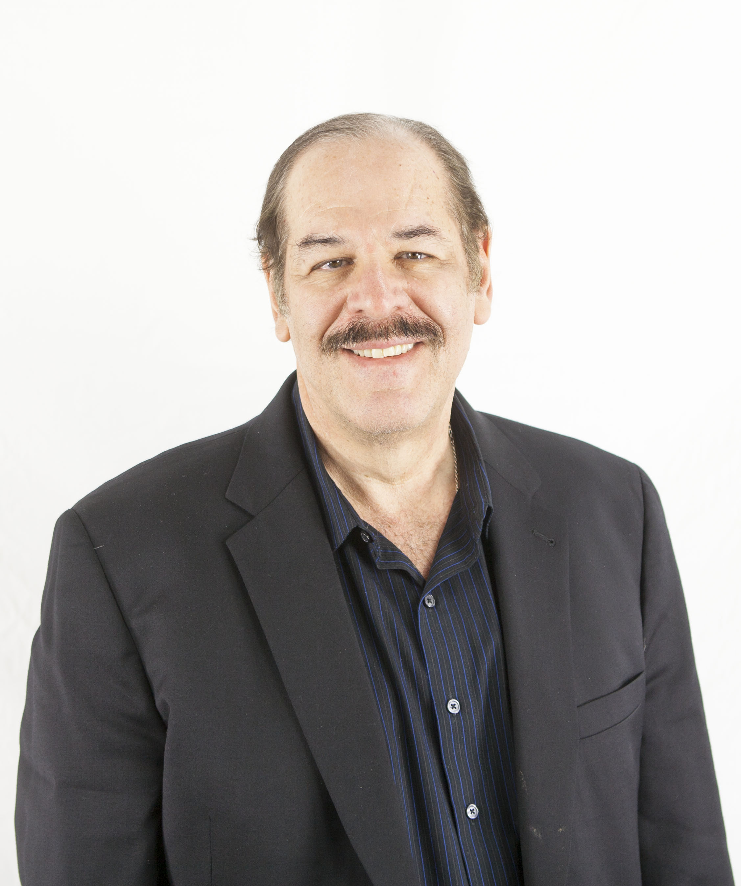
Email: asalander@hindlepowerinc.com
Phone: 1-(610) 330-9000, Ext. 223
Art has spent 50+ years in the stationary battery/dc power industry. Among his accomplishments, he has spoken for many industry groups and published numerous articles and papers on industry relevant topics. Further, he generally is requested to provide presentations on topics ranging from Battery History, sizing batteries and battery chargers, specifying assistance and much more. Art’s other accomplishments include being the Chairmen of the IEEE Energy Storage and Stationary Battery (ESSB) Committee’s WG2405 to work with and update the NEMA PE5 standard for utility battery chargers. Currently, Art Salander provides application engineering and business development for HindlePower, Inc., the leader in utility battery chargers and related dc He holds a physics/engineering degree from Adelphi University with post-graduate studies at NYIT, and he is an IEEE life senior member.
Eric Cogorno
Email: ecogorno@hindlepowerinc.com
Phone: 1-(610) 330-9000, Ext. 212
Eric is a member of the sales and marketing team at HindlePower, the leader in utility battery chargers and dc equipment. Prior to joining HindlePower, he graduated from Lincoln Technical Institute and more recently Albright College. Over his 13 years with the company, he has developed vast knowledge and experience in the manufacturing, testing, and design of stationary battery chargers. Further, he has developed application experience in the battery/dc power industry as a whole and is well versed in sizing chargers and specifications. Eric has also attended and participated in the IEEE Energy Storage and Stationary Battery (ESSB) Committee’s WG2405 that is working to update the NEMA PE5 standard for utility battery chargers.

